User Guide

This user guide serves as a reference manual for an already running application.

**Logging in:** The first portion of the application that any user will encounter is the login screen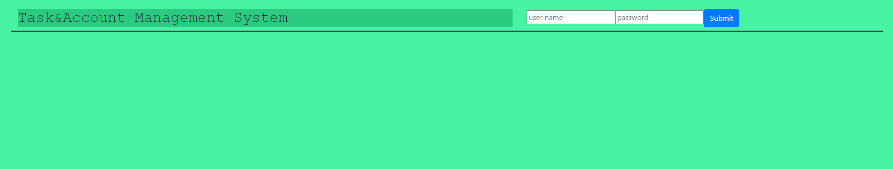

In order to log in a user needs to enter their case sensitive username and password into the provided fields then either press enter or click the submit button

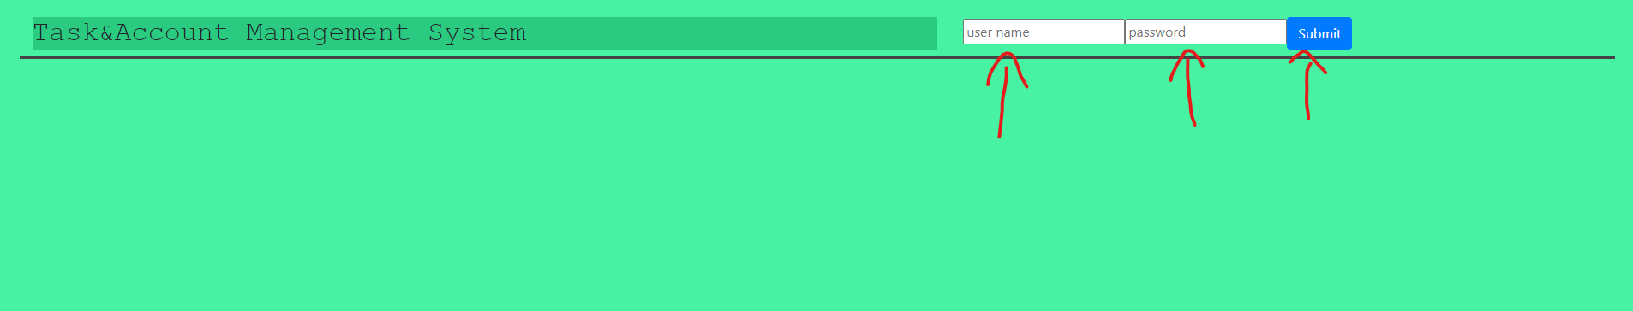

If an incorrect username password combination is provided an error message will be shown

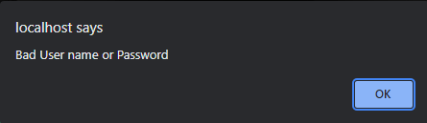

At this point the user pathways will diverge elevated users (Administrators, Managers, and Supervisors) will see this screen:

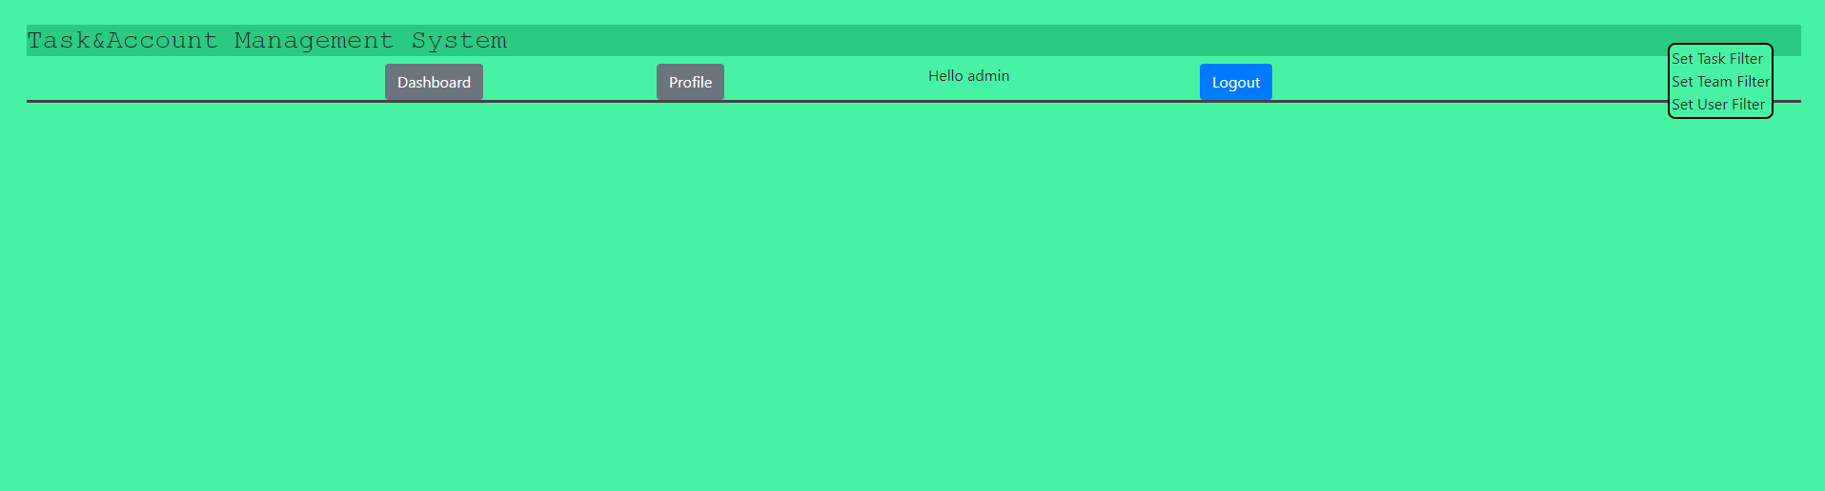

And standard users will see this screen:

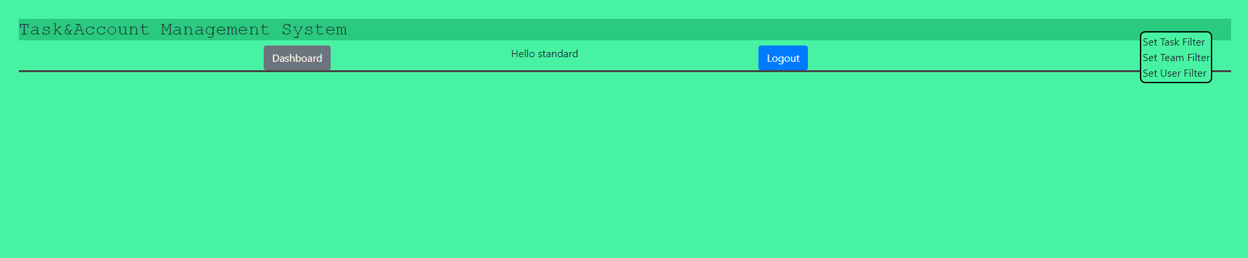

From both screens the logout and filter functions are the same and will be discussed together.

Also the standard user dashboard and elevated user profile have the same functionality and will be covered together.

**The Shared interface:**

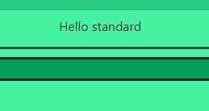

The greeting displays the name of the user that is logged in.

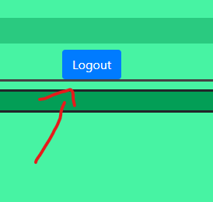

The logout button will delete the stored user tokens and return the user to the login screen

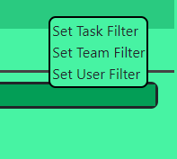

The filter resides in the top right corner of the application when logged in. clicking on any of the set options will open up a filter menu that will filter display of all other components on the application.

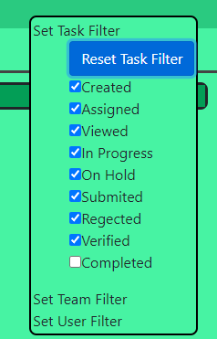

Only selected status options in the task filter will be displayed elsewhere in the program. Clicking Reset Task Filter restores the filter to the initial state. The initial state of the task filter shows all tasks that are not completed.

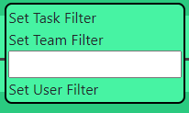 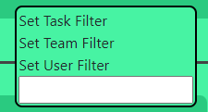

Both the Team and user filters filter by the name field of the respective object. Any text entered these fields will filter any object that doesn’t match the respective filter from the beginning of the name in a case insensitive manor

**The Enhanced User Dashboard:** Users other then standard users will get a different interface when clicking on the Dashboard button. Each seen menu will bring up a list off all objects of the type and allow users to create new objects of each type. If updates to any of the components inside the menus on the Dashboard are not viewable after submission collapsing and reopening the menu will force all sub-components to update.

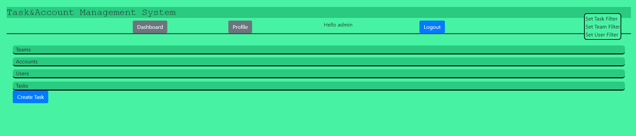

Supervisors get a slightly different version of the Enhanced User Dashboard that does not include Account management.

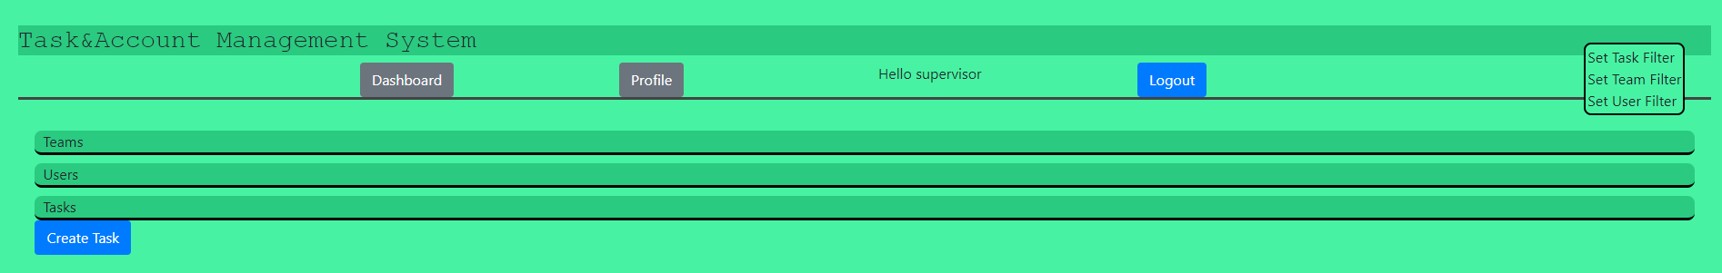

**The Profile component:** For a standard user clicking Dashboard or for an elevated user clicking Profile will bring up a window that displays the User component corresponding with the logged in user.

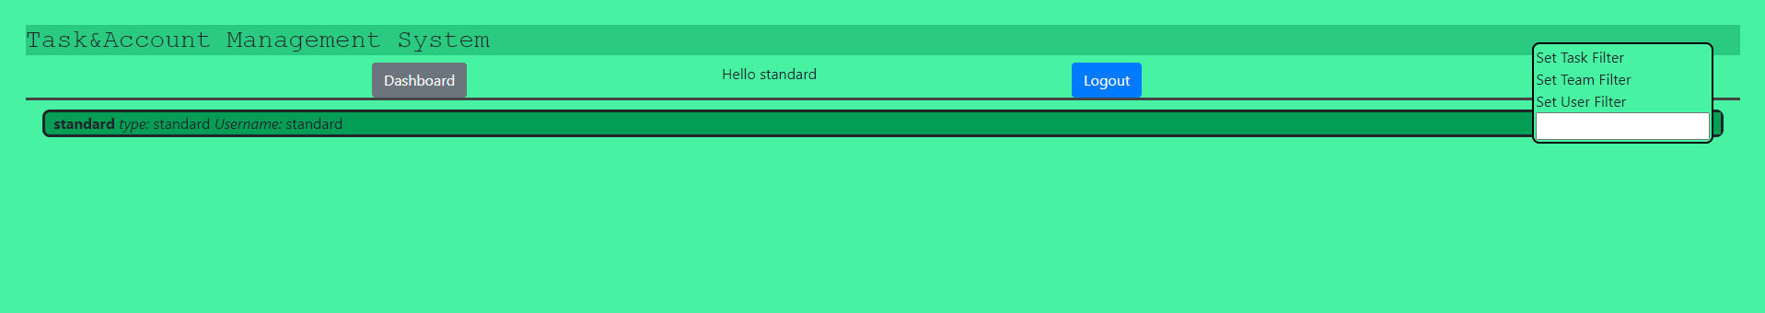

**The User Component:** The user component allows a user to see detailed information about an individual user. Depending on how deeply the component is imbedded inside of other components the user’s teams, tasks, or edit mode may be hidden.

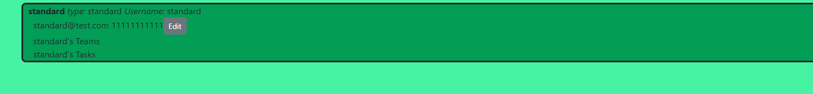

After clicking on the user component, it will expand and show the users contact information and the edit button may be visible.



Clicking the edit button will place the user into edit mode. This allows the users to edit the target user’s name, email address, phone number, and password.

* Clicking submit will update the user’s information in the system and return the user to the previous screen. This may not be fully shown until the next time the user logs into the system.
* Clicking Reset will restore the shown fields to their state when the window was opened.
* Clicking cancel will return the user to the previous screen without making any changes to the user.



For user accounts other than their own managers and administrators will get a slightly modified menu that includes an access change selector and a reset password button.

* The change access dropdown will change the user’s level of access when changes are submitted.
* The Reset Password button will immediately change the user’s password and display the new password on the screen

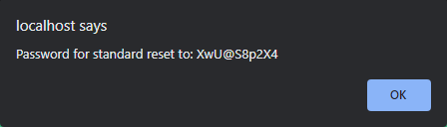

Supervisors also get a slightly modified version of the menu that does not allow for resetting of passwords

If the user’s teams and tasks options are shown clicking on either button will display a list of the respective teams or tasks associated with the user.



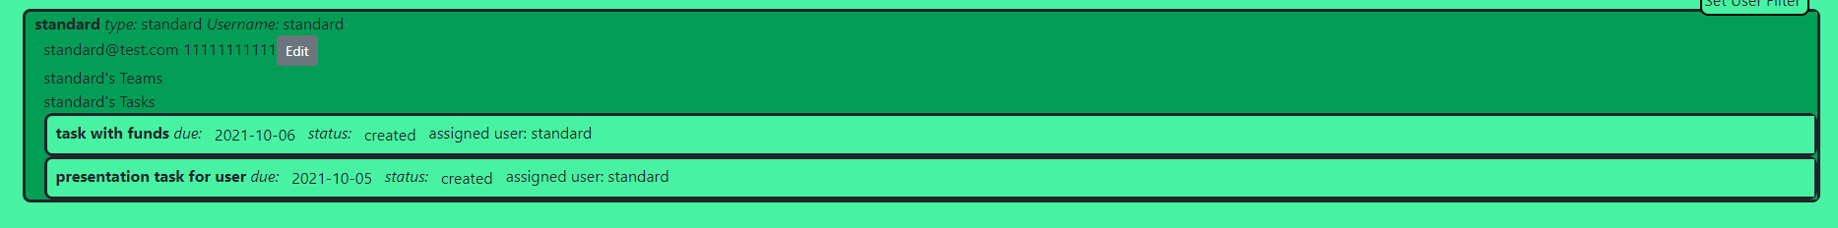

**The Team Component:**



When collapsed the team component will show the name of the team as well as the supervisor responsible for the team



After clicking on the team component if available the option to view members of the team as well as tasks assigned to the team will be shown. Depending on how the team component is imbedded inside of other components one or both options may be unavailable.



When opening the team component an Administrator or Manager will get the option to edit the team



Clicking the edit button will put the team into edit mode where the user can change the team’s name, the team supervisor, or the team’s description.

* Clicking submit will send the updates to the server for recording and return the user to the previous screen. Updates may not be available till after the component is reset.
* Clicking reset will discard the changes and reset the menu to its initial state
* Clicking cancel will return the user to the previous screen



When the team members or assigned tasks are opened the respective list of objects assigned to the team will display inside the respective menus.

**The Account Component:**



When collapsed an account shows its name, the balance in the account, as well as the amount allocated to sub accounts and tasks.



After clicking the account, it is expanded to show the contact’s name for the user responsible for the account.

* Clicking the edit button opens the edit menu from this menu a user can change the account name and edit the account balance. 
  + Clicking edit funds in this menu opens the transfer sub menu
    - In the transfer sub menu clicking deposit or withdraw funds will attempt to change the balance of the account positively or negatively respectively. If there is not sufficient funding available a withdrawal will fail
  + Clicking submit changes will submit the name change and return the user to the previous screen
  + Clicking reset edits will restore the editor to its default state
  + Clicking cancel will return the user to the previous page.
* Clicking view transactions will bring up the transactions sub menu 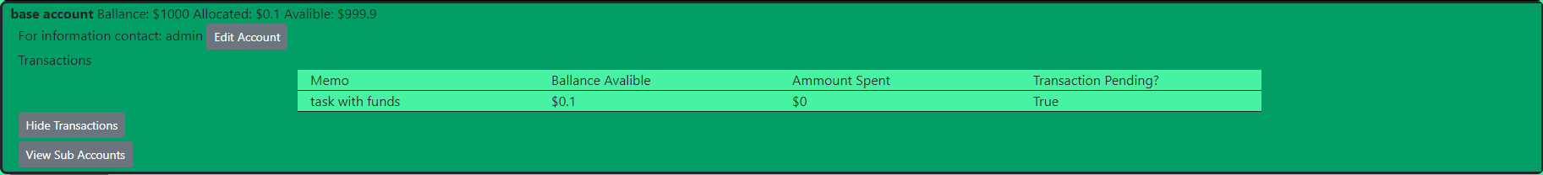
  + The transaction menu will display a table with the names of all the tasks that have had funding assigned from the account, the balance that is assigned to the task, the ammount that has already been spent and if the task is complete.
  + Clicking the Hide transactions button will return the user to the previous screen
* Clicking the view sub accounts button will open the sub accounts list. This will display all the sub accounts associated with this acocunt 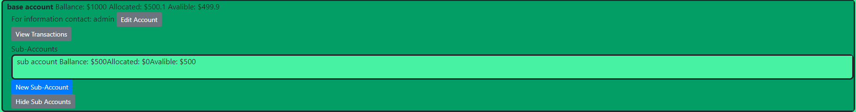
  + If avalible the new sub account button will open the new sub account sub menu 
    - From the new sub account menu a user can create a sub account associated with the account. The ammount transferred in will be allocated in the main account and will be unavalible for other purposes.
    - The rest of the menue follows the same patern as creating a new account.
  + More information about sub accounts will be discussed in the sub account component section
  + Clicking hide sub accounts will collapse the sub accounts menu

**The Sub Account Component:**



Sub accounts are nested inside of the account they belong to. When collapsed they show the sub account’s name, the balance in the account, how much of the funds assigned to the account are allocated to tasks, and how the funds that are available to be allocated.



Opening the sub account component gives access to the sub menus for the sub account

* Clicking the edit account button places the component into edit mode 
  + In edit mode the user can change the name of the sub account.
  + Clicking submit changes will submit the name change and send the user back to the previous screen
  + Clicking reset edits will set the name of the compoent back to it’s initial state.
  + Clicking cancel will return the component to normal mode and close the editor
* Clicking transfer funds will open the transfer sub menu 
  + In the transfer sub menu a user can enter an ammount to transfer into or out of the sub account from the main account it is associated with.
  + Clicking the allocate funds button will check to see if the funds are avalible in the main account and if so they will be allocated to the sub account
  + Clicking the release funds button will check to make sure that the funds are avalible in the sub account then release them back to the main account.
  + Clicking cancel transfer will close the transfer menu without making changes to the sub account’s balance or effecting the main accounts allocations
  + Any actions in this menu if sucsessfull will return the user to the previous screen
* View transactions will have the same behavior as it does in a main account showing the transactions report for the sub account. Hide transactions will return the user to the previous screen

**The Task Component:** The task component is the main record of work in the application. 

When collapsed the task component will show its name, due date, current status, and the user or team that the task is assigned to. If the task is not complete and is either overdue or due today a red marker will be shown at the bottom of the task



When expanded If there are funds assigned to a task or anything has been spent on the task it will show up in the expanded view. In addition, the note report will be visible.

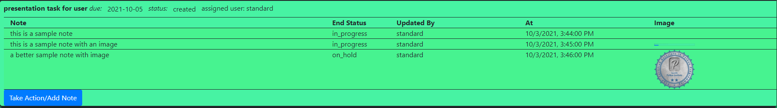

The note report will include the text of the note, the status of the task at the time of the note, the name of the user that entered the note, the date and time the note was entered, as well as an image if there was one entered with the note.

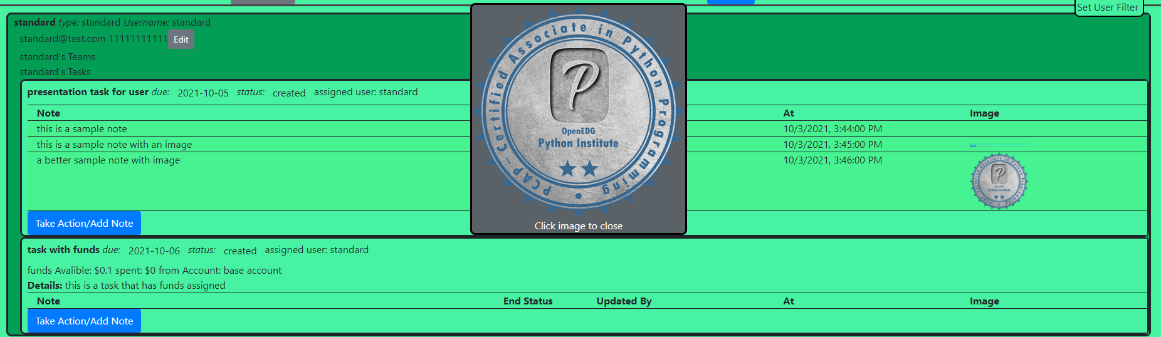

Clicking the image (if available) on the note will open the image in the middle of the screen so it can be seen better. To close the image, click anywhere on the image.

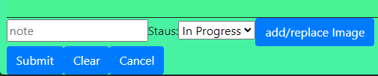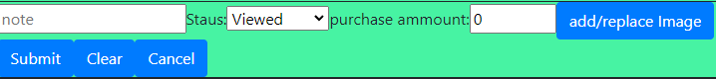

Clicking the Take Action/Add Note button will bring up one of two different versions of the add note sub menu depending on if there are funds available to the task. In either version the user can add text and change the status of the task. If there are funds available, the user will also have the option to add a purchase amount. If the task is marked as requiring manager verification the task will not allow a standard user or supervisor to mark the task as completed or verified. In addition, if any funds are to be recorded in this note an image of the receipt must be included with the note.

* Clicking add/replace image will open the add image sub menu (shown and described below
* Clicking submit on the add note menu will update the task and append the note to the task.
  + If there were funds spent the menu will validate that no more then what was available was spent and that there is an image attached.
  + If the end status is completed any unspent funds will be released and the balance for the allocation will be set to 0
* Clicking clear will reset the menu
* Clicking cancel will close the menu

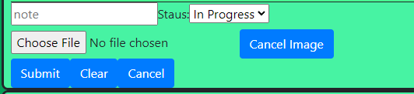

the choose file sub menu consists of two buttons one to select an image and one to close the sub menu (cancel image)

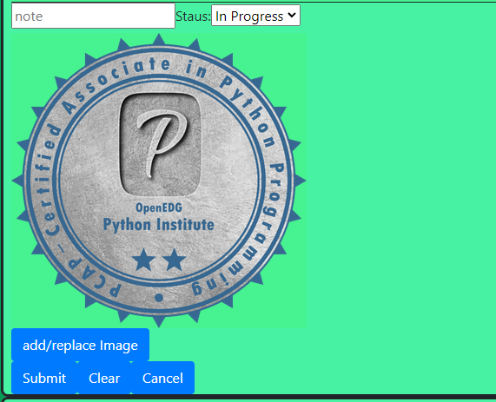

If an image is selected the menu will be closed but the image will be displayed alongside the note. If a user goes back into the add/replace image sub menu they can remove the image or replace it with a new one. Only one image can be stored along with a single task note.



Enhanced users also get the ability to edit or delete tasks

* Clicking edit will place the component into edit mode this will allow the user to edit the name, due date, discription of task, status, toggle if the task requires a sign off, as well as change who the task is assigned to.
  + Clicking submit will update the task and move the component out of edit mode as well as add a note that the component was edited
  + Clicking reset will place the component back to its initial state
  + Clicking cancel will close edit mode without making any changes to the task
* Clicking delete will delete the task as long as there have been no funds spent and there are no allocated funds. (*If funds have been alocated but none have been spent adding a note and setting the task to complete will release the funds so it can be deleted)*